**Creating and maintaining s3 bucket using terraform**

1.Initializing terraform and provider

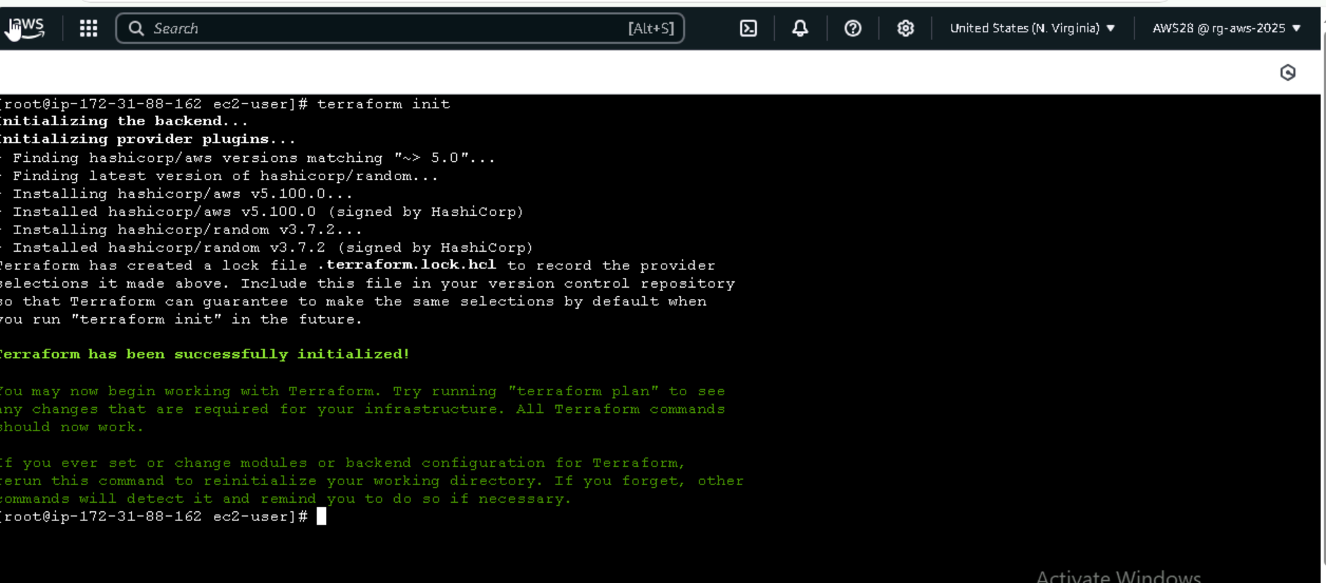

**Aws code pipeline to run a terraform scripts:**

Connection to code commit

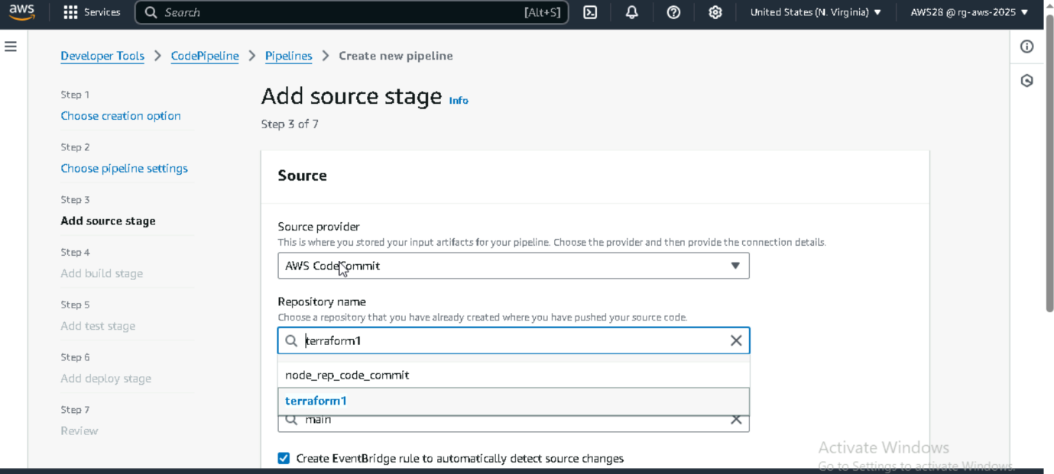

**Code build:**I have added a build stage andfor build terraforminit,plan,apply

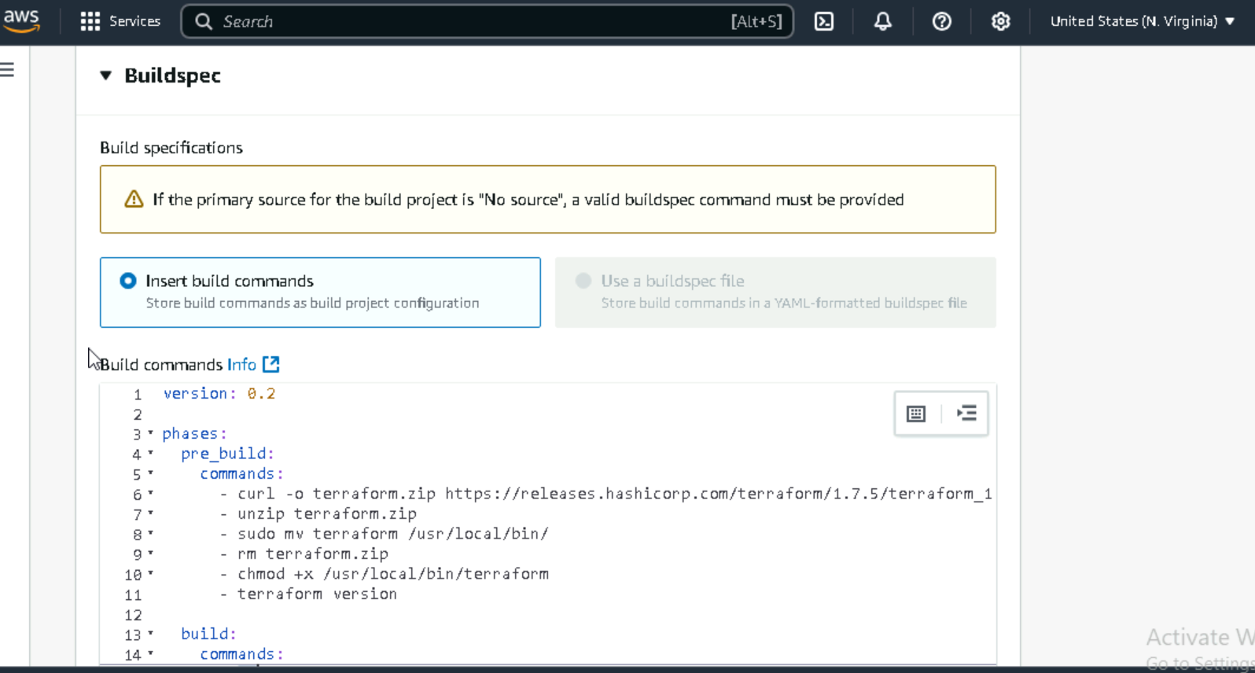

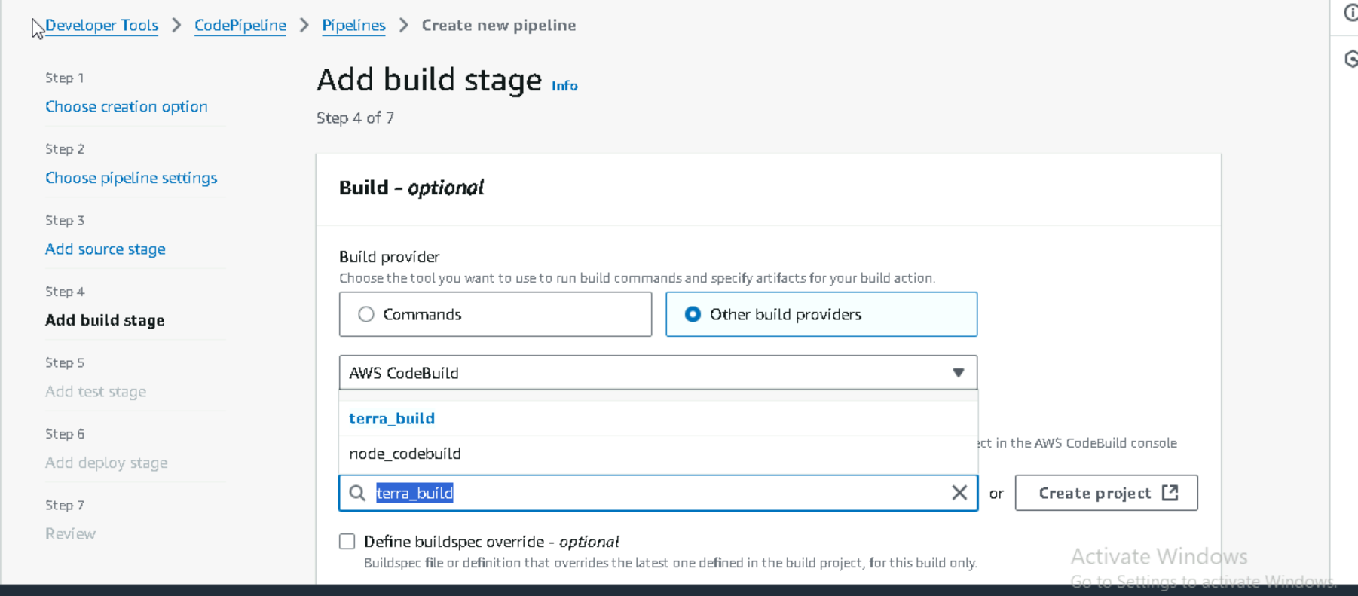

**Deployed and verified**

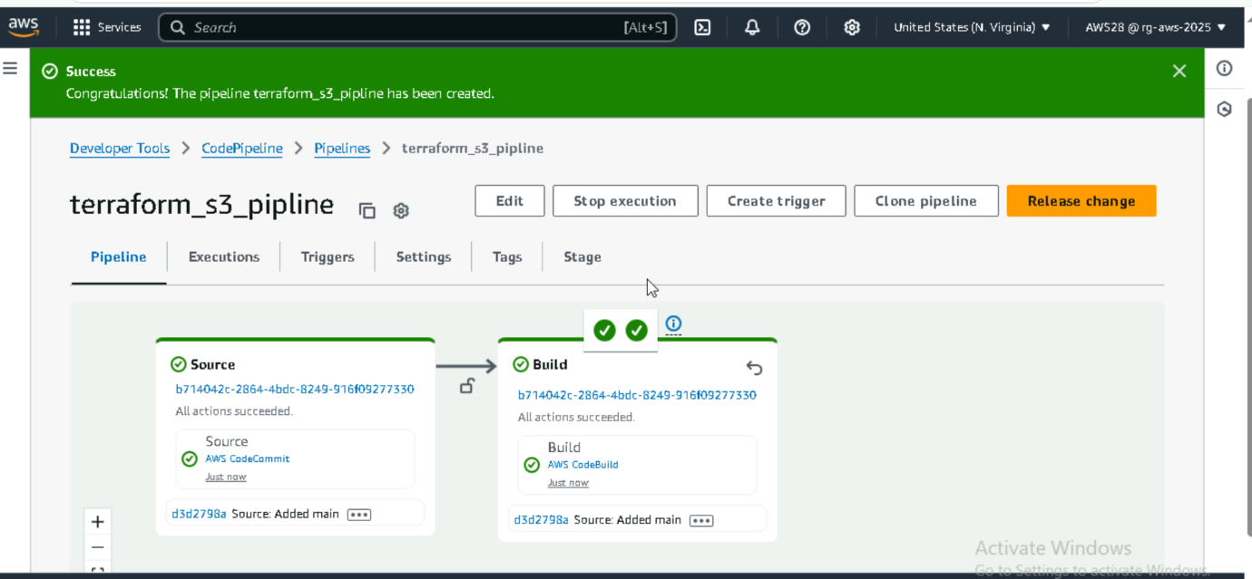

Store terraform files in aws code commit :

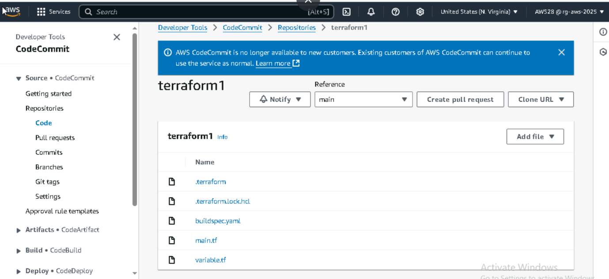

**S3 bucket**

